TOWN OF GREAT BARRINGTON

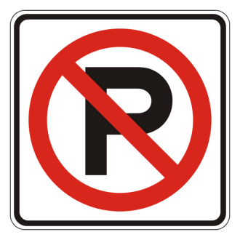

Warning

The Winter Parking Ban on all overnight on-street parking on town streets is in effect From November 15th through March 30th between the hours of 01:00 AM and 06:00AM. Please be advised that violators will be ticketed and vehicles that block DPW snow plows will be towed at the owner’s expense. Overnight parking is permitted in many parking lots in the downtown area including the Town Hall lot, the top of Railroad Street lot, the Castle Street lot and the Mason Library lot.

On November 1st and at times throughout the two-weeks prior to the start of the overnight parking ban, the Great Barrington Police Department will issue warning notifications to inform all, of the upcoming start of the parking ban.

Your cooperation in this matter is appreciated.

