TOWN OF GREAT BARRINGTON

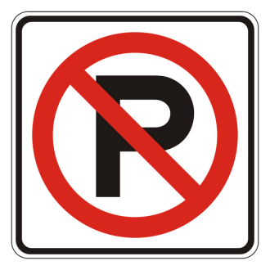

Warning

Effective February 12, 2018

The Winter Parking Ban on all overnight on-street parking on town streets is in effect From November 15th through March 30th between the hours of 01:00 AM and 06:00AM. Please be advised that violators will be ticketed and vehicles that block DPW snow plows will be towed at the owner’s expense. Overnight parking is permitted in many parking lots in the downtown area including the Town Hall lot, the top of Railroad Street lot, the Castle Street lot and the Mason Library lot.

Your cooperation in this matter is appreciated.

